Assignment 1 – Classification using Scikit-learn
Student Name: Jeffrey Reynolds Student ID: 22462474 Programme: 4BCT

Algorithm 1 – Decision Tree Regressor
Decision Tree Regressor is a supervised learning algorithm used for regression tasks, used to predict continuous numerical values using a tree-like structure. The tree operates by recursively splitting the dataset based on features that minimise prediction error. This tree structure is then traversed for new predictions based on features being greater than or less than the node values in the tree, reaching prediction values at the leaf nodes after this process. [1]
Detailed Description of Algorithm 1.
Decision Tree Regressor continuously splits the training data into subsets, minimising the prediction error in the process and forming a tree-like structure. Each node then represents a decision rule on a feature, each branch representing the outcome of a decision, and each node representing a predicted value. [2] When building the tree, the algorithm must determine where to split the data at each node. This is accomplished by calculating the Mean Square Error (MSE) of the target variable when considering a split at each node.
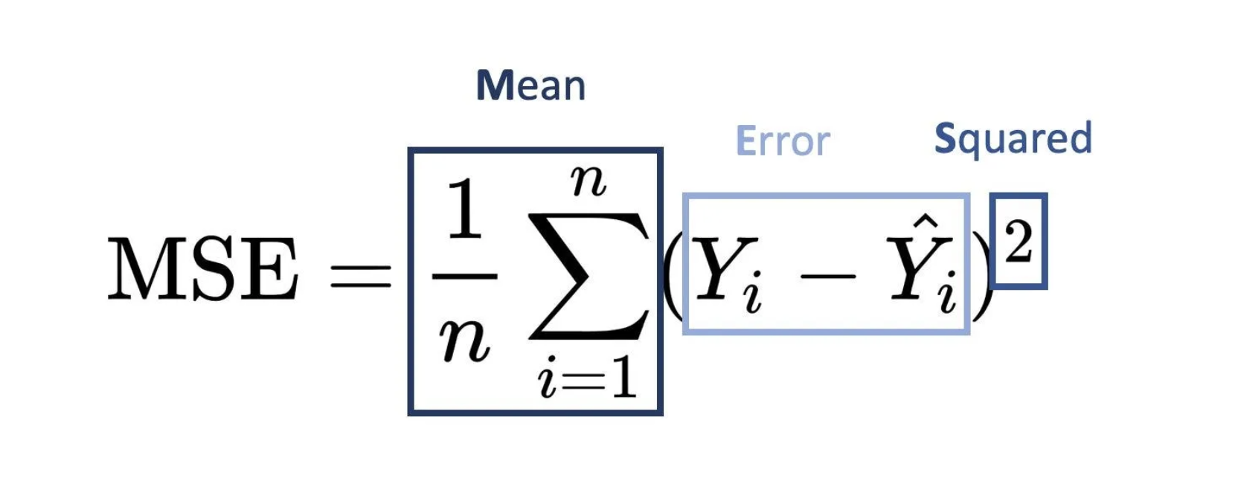
Figure 1 -Mean Square Error Formula [2]
N = Number of data points in the node,
Y_{i} = Target value for observation I,
Ŷ_{i} = Mean
Each potential split is evaluated for each left and right child node and the one that maximises error minimisation is chosen. Once this is chosen, the data is split into two subsets and recursive binary splitting takes place on these subsets until a stopping condition is met. This condition can be set as a hyperparameter.
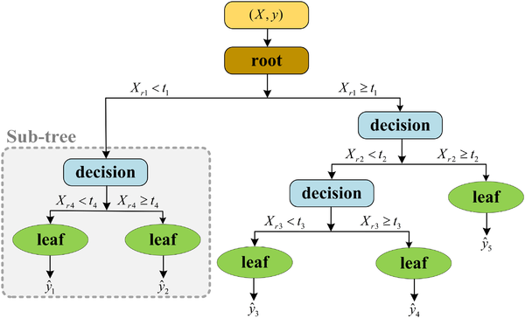
Figure 2: Graphic illustration of algorithm tree structure [3]
Why I choose this algorithm.
One of the main reasons I chose this algorithm is because of its interpretability, allowing me to visualise and interpret how each feature influences predictions. This algorithm also is especially good at capturing non-linear relationships between features helping in furthering my understanding of the data set and each features influence. In this vein, the algorithm automatically handles feature interaction without the need for any explicit feature engineering. This interpretability helps a lot with comparison to other models for measuring performance also, which is particularly helpful in the context of the assignment.
Hyperparameter Details for Tuning.
max_depth: Sets the maximum depth of the tree, this hyperparameter is important to balance as it can lead to overfitting if set too high, and underfitting if set too low. [4]
min_samples_leaf: The minimum number of samples required to be at a leaf node, a split will only occur if it leaves at least the value of min_samples_leaf samples in each resultant branch. [4]

Algorithm 2 – Random Forest Regressor
Random Forest Regression is an ensemble learning method that works by creating multiple decision trees (using the same underlying algorithm in the Decision Tree Regressor model) each trained on a random subset of the dataset. [5] This randomness in the feature subset selection reduces correlation between the trees. This random ensemble approach reduces overfitting that occurs in single decision trees. Predictions are then made by averaging the outputs of all individual trees, with each tree contributing equally to the final predicted value.
Detailed Description of Algorithm 2.
The first step in the process is called bagging, a form of bootstrap sampling, where random rows of data are taken to form training sets for each of the trees. [5] A random forest regression model will then combine these trees into a single ensemble model. Each tree is built from the aforementioned subsets of the data. Each of these independent trees makes their own predictions during the prediction stage, these predictions are then used to take a weighted average of all the trees’ predictions. This process reduces variance and improves accuracy by combining these individual outputs. The approach allows capturing complex relationships between features better than any single decision tree. [6]
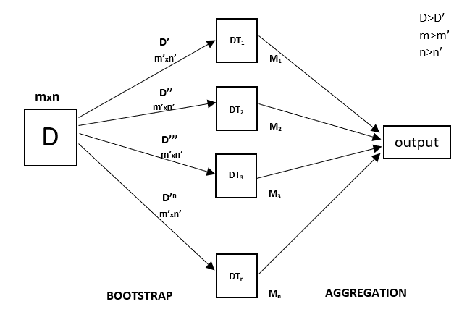
Figure 3: Illustration of random forest regression algorithm [6]
Why I choose this algorithm.
I chose this algorithm due to its improvement over single decision trees as the previous algorithm I had chosen, this choice provides the opportunity to compare and analyse the improvements the ensemble method provides. The tree and ensemble nature of this algorithm causes it to handle non-linear relationships well and especially provides robustness to noise and outliers due to the ensemble learning technique. As with a single decision tree regressor, this algorithm provides a straightforward way to measure the influence of individual features in terms of their effect on tensile strength. This information is valuable to understanding the insights contained in the dataset.
Hyperparameter Details for Tuning.
n_estimators: The number of trees in the random forest. This hyperparameter is important to balance as the forest can be undersized or oversized leading to underfitting or overfitting respectively. [7]
max_depth: Sets the maximum depth of each individual tree, this hyperparameter is important to balance as it can lead to overfitting if set too high, and underfitting if set too low. [7]
Algorithm 1 – Decision Tree Regressor - Model Training and Evaluation
The objective in training this model was to predict tensile_strength based on the steel dataset. In the process of this training, 10-fold cross validation was applied to ensure reliability and reduces the bias-based errors that can arise from training on a single training/testing data split. The two metrics I have selected to measure performance are,
- R2 Score: Measurement of how well the model explains the variance in the dataset.
- Mean Absolute Error (MAE): Measurement of the average error in the units of tensile_strength
Data Preprocessing and Visualisation
The data was split into a training set comprising of 80% of the data, with the test set comprising 20% of the data. The 80% set for training uses 10-fold cross validation was applied to eliminate any bias in these selections. All features in the dataset are factored into the regression prediction for tensile_strength.
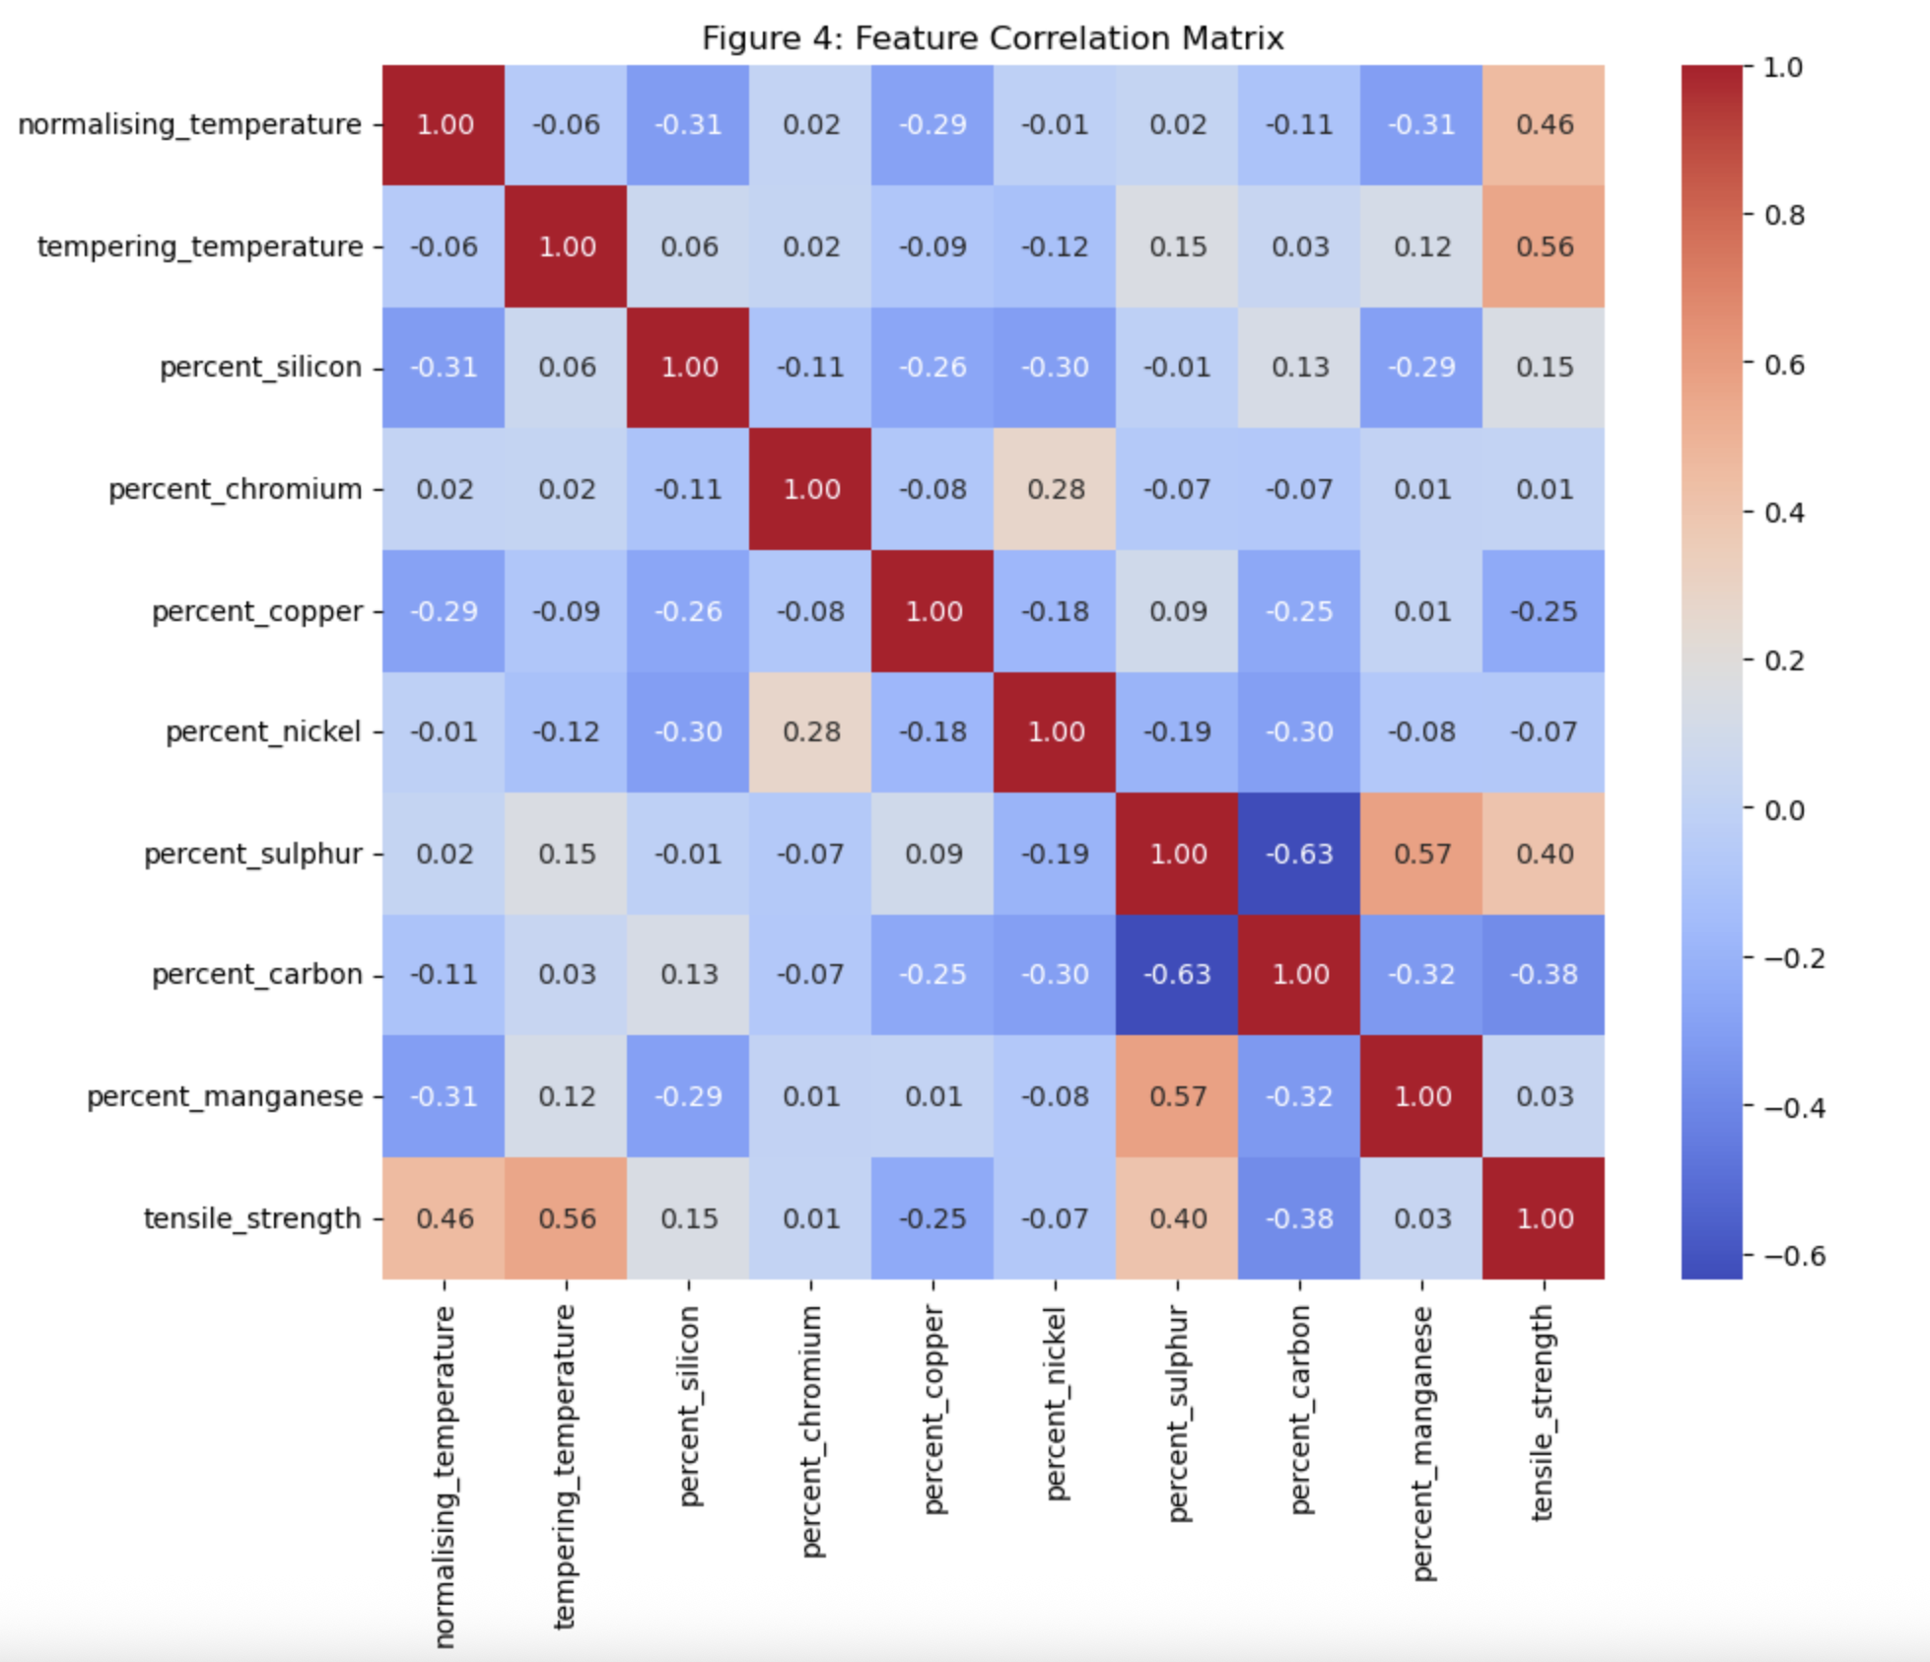
Figure 4: Correlation matrix illustrating weights between datapoints in the dataset
Training and Evaluation Details
The model was trained on default parameters and on tuned hyperparameters. For the default model, the training average R2 was 1.0, with a MAE average of 0.0. This shows that the model perfectly memorised the training data under these conditions. The testing R2 average was 0.7323 with a MAE average of 30.8. In a well-tuned scenario these values should be substantially closer showing a overfitting problem with the default conditions. After tuning max_depth and min_samples_leaf using GridSearchCV from scikit-learn, the best hyperparameters found were max_depth: 15, and min_samples_leaf: 1. This resulted in a slightly reduced training fit with better testing results. With an average testing R2 to 0.7458, with an average MAE of 30.1222.
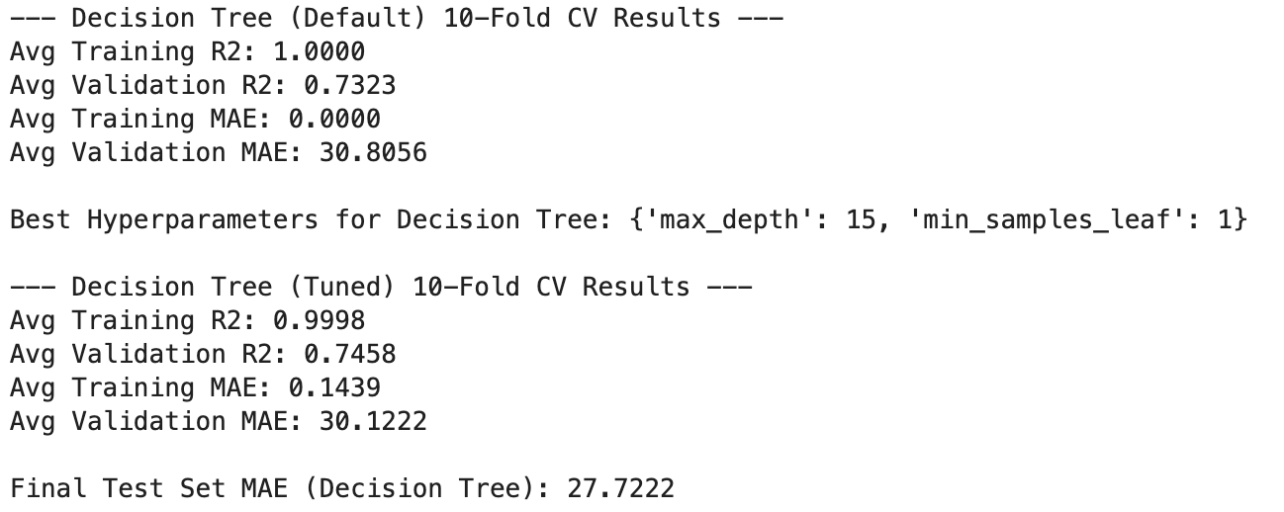
Figure 5: Summary of Results Achieved from Training and Testing
Discussion of results
The tuned model did not perform substantially better than the default model in training, with an exhaustive search through hyperparameters not resulting in a substantial reduction in MAE. This suggests that the Decision Tree Regressor model struggled to generalise well across this dataset regardless of tuning. This conclusion is further supported by the fact that the best min_samples_leaf hyperparameter value was 1, causing the tree to grow specific single-point data branches. Increasing this value did not fix the overfitting problem. As shown in the results, a final test on the 20% testing split of the test set resulting in a lower MAE of 27.7222, further enforcing the models struggle to generalise to this dataset.
Algorithm 2 – Random Forest Regressor - Model Training and Evaluation
The prediction objective for the second algorithm remains the same as the Decision Tree Regressor. The Random Forest Regressor was chosen to compare and potentially address the issues with overfitting and variance in the case of the single decision tree. 10-fold cross validation with the same performance metrics were selected.
Data Preprocessing and Visualisation
The exact same training and test sets were used for the Random Forest Regressor as for the Decision Tree Regressor. This was done to ensure the validity of comparisons between the ensemble training method as opposed to the single decision tree.

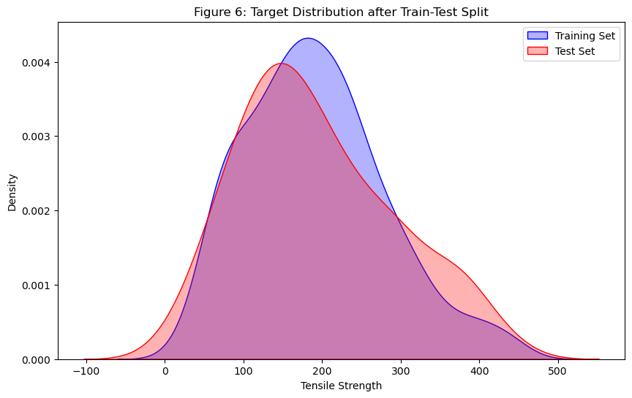
Figure 6: Visualisation of the tensile strength across training and test set
Training and Evaluation Details
The default tuning results for the Random Forest model resulted in an average R2 testing value of 0.8557, substantially better than even the tuned Decision Tree value. With an average R2 training value of 0.98 on the default model, the gap between the testing and training R2 is substantially better than the Decision Tree showing better generalisation. For the tuned model, the best n_estimators value was 200, with no limit on max_depth. This tuning resulted in a slight improvement over the default with an average testing MAE of 24.1644 on the tuned model and better R2 value over the default.
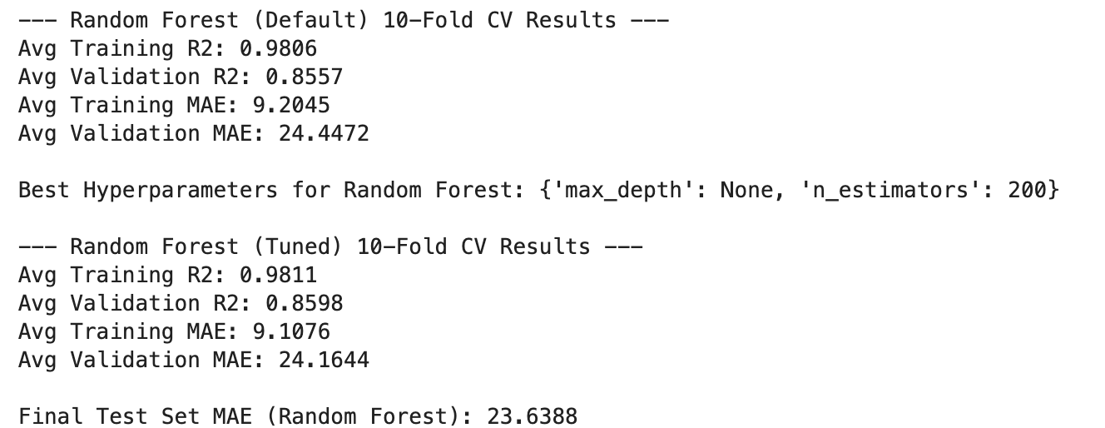
Figure 7: Summary of Results Achieved from Training and Testing

Discussion of results
This model worked substantially better than the Decision Tree model because of the ensemble training effect on the results. With identical training inputs and optimised hyperparameters in both cases, the model itself remains as the defining difference. This ensemble training method better handled noise that was caught as relevant features in the single decision tree. The best hyperparameter values had a max_depth of None, indicating that the trees in the forest were deep and complex, but the large number of trees (200) mitigated the risk of overfitting from overly complex individual trees.

Conclusions
The Random Forest model performed substantially better than the single Decision Tree model. This is due to the ensemble training method that Random Forest employs, significantly reducing overfitting problems present in the Decision Tree.
Key Findings
- The Random Forest reduced the MAE by 6 units from approximately 30 in the DT model to 24 in the RF model.
- Individual Decision Trees were highly prone to overfitting on this dataset.
- Both the Decision Tree and Random Forest performed very well prior to tuning with only minor improvements in the tuning process.
- The 20% test set split for a final unseen test on both models had a lower MAE than the validation averages, with RF test MAE: 23.63 vs DT test MAE: 27.72)
Comparative Analysis of Algorithm Performances
As seen in the side-by-side comparison in Figure 8, the Random Forest model (represented in green) substantially outperforms the Decision Tree model (represented in blue) in both achieving a higher R2 score, and a lower mean average error on both the default and tuned variants. The Random Forest model achieved a 20% increase in R2 score over the Decision Tree and a 20% decrease in MAE.
Both models are very similar in their performance increases after tuning, both showing only a marginal increase in performance post-tuning for R2 and MAE scores.
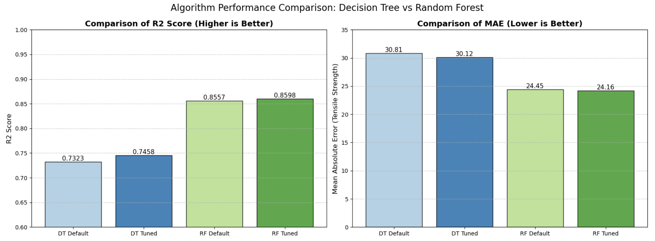
Figure 8: Graphed comparison of results from the two algorithms
Recommended Hyperparameter Valued based on Results
Decision Tree Regressor max_depth: A max_depth of 15 was found to be best at reducing the overfitting problem but not substantially due to model limitations.
Decision Tree Regressor min_samples_leaf: A min_samples_leaf of 1 was found to be best but had the same problem of struggling with overfitting single-data-points.
Random Forest Regressor n_estimators: A n_estimators of 200 provided the highest stability and lowest MAE.
Random Forest Regressor max_depth: A max_depth of None provided the highest stability and lowest MAE.
Concluding Remarks
The Random Forest Regressor, as expected, performed substantially better than the single decision tree alternative. This performance increase was due to the ensemble model having the advantage at reducing overfitting. With an average MAE of about 24, the models predictions are on average within 24 units of the actual tensile_strength. Given that the average tensile_strength across the data is 192.05, this represents an error margin of 12.31%. In a real world scenario, for accuracy, further model experimentation would be ideal to further reduce the MAE. The R2 value of 0.86 in the tuned Random Forest model is considered good and captures 86% of the variance.
References
- [1] Samy Baladram, “Decision Tree Regressor, Explained: A Visual Guide with Code Examples | Towards Data Science,” Towards Data Science, Oct. 10, 2024. https://towardsdatascience.com/decision-tree-regressor-explained-a-visual-guide-with-code-examples-fbd2836c3bef/
- [2] FARSHAD K, “Understanding Decision Tree Regressor: An In-Depth Intuition,” Medium, Oct. 30, 2024. https://farshadabdulazeez.medium.com/understanding-decision-tree-regressor-an-in-depth-intuition-a1d3af182efd
- [3] H. Yazdani, M. Doostizadeh, and F. Aminifar, “Forecast‐aided power and flexibility trading of prosumers in peer to peer markets,” IET Renewable Power Generation, vol. 17, no. 4, pp. 920–934, Nov. 2022, doi: https://doi.org/10.1049/rpg2.12645.
- [4] scikit-learn, “sklearn.tree.DecisionTreeRegressor — scikit-learn 0.23.2 documentation,” scikit-learn.org. https://scikitlearn.org/stable/modules/generated/sklearn.tree.DecisionTreeRegressor.html
- [5] GeeksforGeeks, “Random Forest Regression in Python,” GeeksforGeeks, Jun. 14, 2019. https://www.geeksforgeeks.org/machine-learning/random-forest-regression-in-python/
- [6] AnalytixLabs, “Random Forest Regression — How it Helps in Predictive Analytics?,” Medium, Dec. 26, 2023. https://medium.com/@byanalytixlabs/random-forest-regression-how-it-helps-in-predictive-analytics-01c31897c1d4
- [7] scikit-learn, “3.2.4.3.2. sklearn.ensemble.RandomForestRegressor — scikit-learn 0.20.3 documentation,” Scikit-learn.org, 2018. https://scikit-learn.org/stable/modules/generated/sklearn.ensemble.RandomForestRegressor.html

Report Update Log
Date | Update Description | Time Spent
10/10/25 | Worked on research and description of first chosen algorithm. | 2.5 hours
11/10/25 | Completed research and work on initial algorithm discussion for two chosen algorithms. | 3.5 hours
25/10/25 | Implemented and reported on algorithm performance, tuning, etc. | 6 hours

GitHub Repository Link

